**POWER BI ASSIGNMENT-3**

**Use Case** - Import list of richest people using Query Editor

**Source** – Richest people

Q1. The raw data – your task is to transform it into something more presentable.

**Requirement**

1. Create a new Power BI Report , and load in the data

Step-1. Open Power BI in your desktop. To import data, click “ Get Data” and select “Excel”.

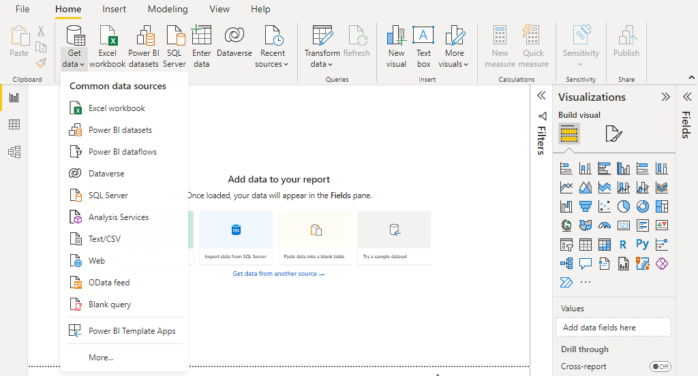

1. Some column have been renamed, while each person’s wealth ( in billions of dollars) has been extracted.

Step-2. Select “Wealthy” data set from your drive, Tick mark the table “Billionaires” and click on “Transform Data”

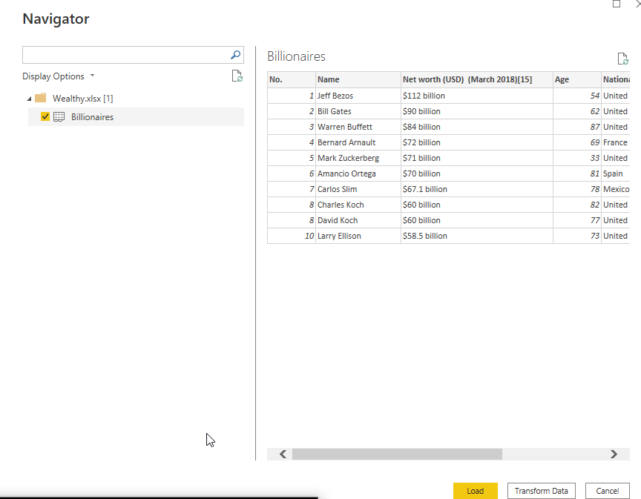

Step-3. Rename some column, First Column “No” as “ Rank” and Column “Net Worth[USD][March 2018] as “Billions($)”.

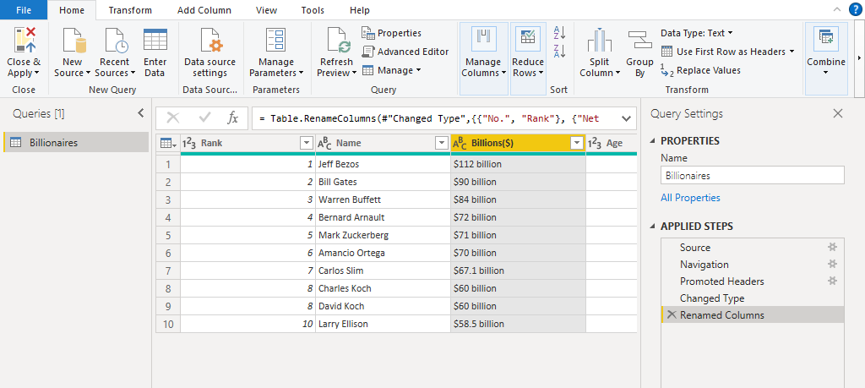

1. Replace the word billion with an empty string.

Step-4. Go to Transform and select “Replace Value” . A window will pop-up , fill “ Value To Find” with “billion” and leave “Replace with” field blank and click OK.

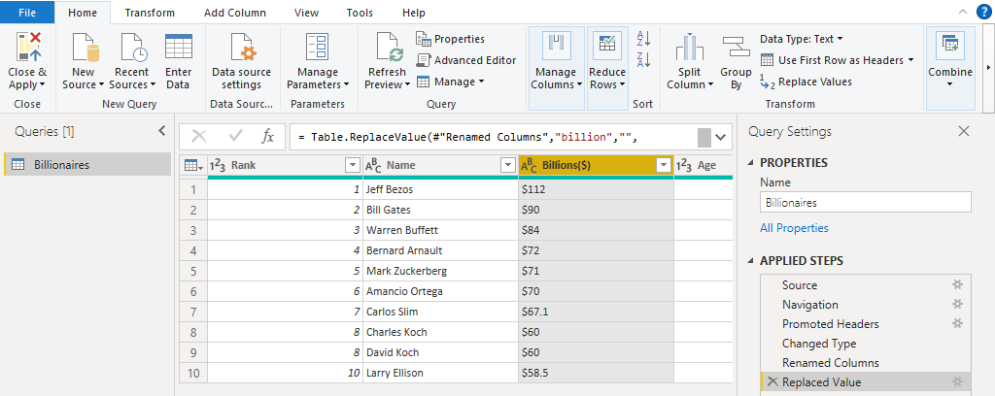

1. Replace the $ symbol with an empty string.

Step-5. Go to Transform and select “Replace Value”. A window will pop-up, fill “Value to find” with “$” and leave “Replace with” field blank and click OK.

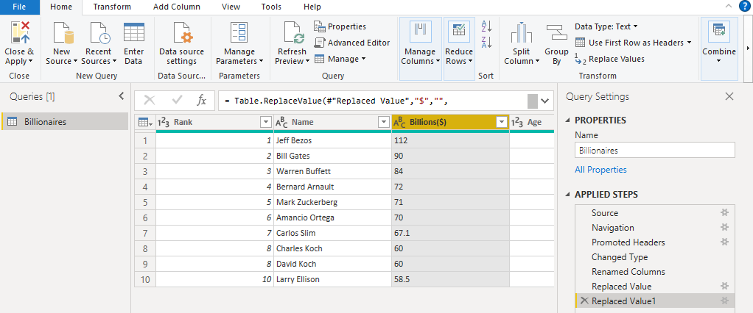

1. Convert the resulting column to a whole number.

Step-6. Go To Transform option in Ribbon and click of “Data Type” and select “whole Number” from the drop down list.

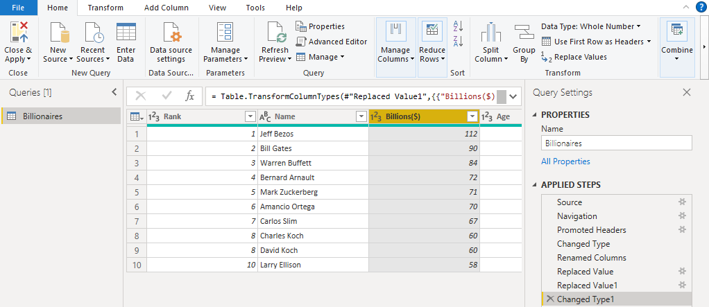

1. Create a chart just to prove that the billions really are being treated as numbers.

Step-7. Add chart for visualization.

